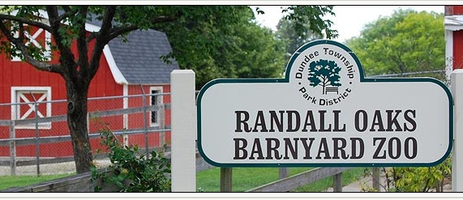

ALL SCHOOL FIELD TRIP

To: Randall Oaks Park and Barnyard Zoo
1180 North Randall Rd., W. Dundee, IL 60118

When: Tuesday, April 26, 2016

Time: 10:30 a.m.

Bring your family for a day at the park. All children must be accompanied by an adult. We will meet at 10:30 a.m. at Randall Oaks to visit the petting zoo, which has a number of farm animals. The zoo will have feed bags available to feed the animals at an additional cost. The park also has a picnic area and playground, which we have reserved. We’re hoping for good weather, so plan on bringing a picnic lunch.

Please note - The school will be closed all day
-------------------------------------------------------------------------------------------
Please return bottom portion to school – RSVP no later than Friday, 4/22

________ We will not be able to attend.

________ Yes, we’ll be there.

Children at $5.00 each – Siblings welcome – Total # of Children ________

Adults at $5.00 each – Total # of Adults _________________________

Total Amount Enclosed ____________________________________

Student(s) Name: ________________________________________

Checks Only. Please make checks payable to MCH

