

*You are invited to a*

Parent Materials Making Workshop

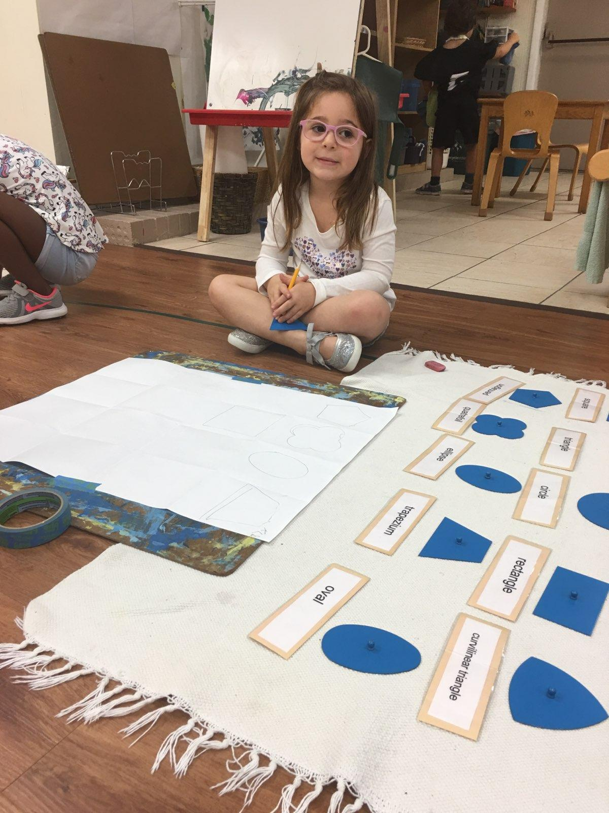

Join us for a morning of making educational materials for your child’s classroom. This is a great way to meet other parents and gain insight into Montessori materials.

**Friday, January 24, 2020 – 9:30 a.m. – 11:00 a.m.**

--------------------------------------------------------------------------------------------

Please R.S.V.P. by Wednesday, January 22nd

☐ Yes, I will be attending the Parent Workshop

Parent Name: ______________________________________________